**Screenshots**

* **Welcome Page**

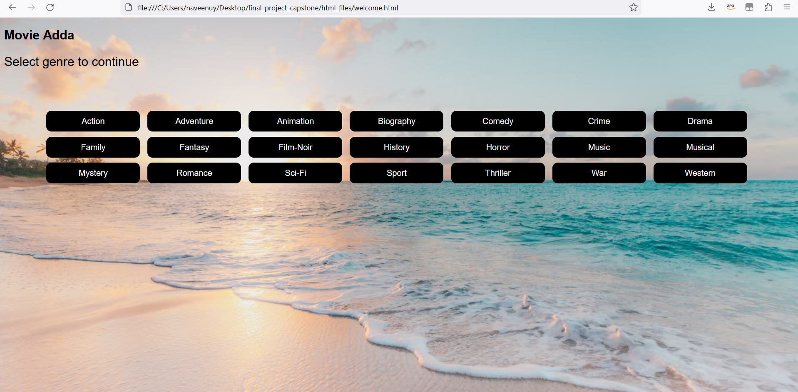

**Clicking Action genre**

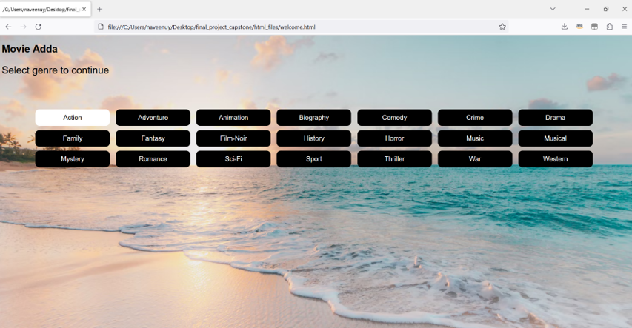

**On clicking Action genre button, routing to Action genre movie details page**

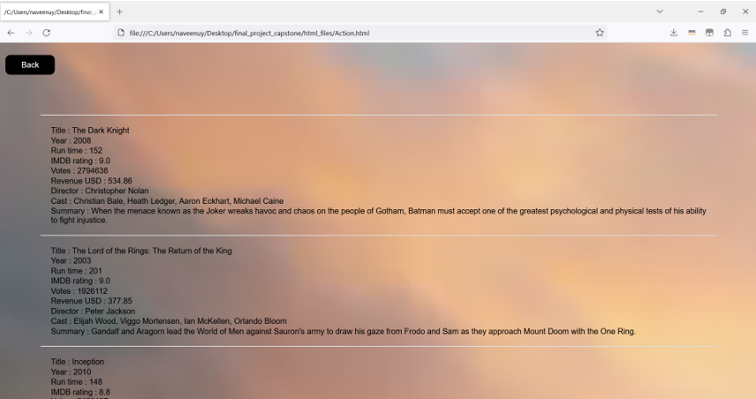

**Clicking back button to route to main page:**

